1/10/2026
LAB NO 04
Operating System Lab
Instructor: Ms. Muneeba Banaras
Submitted By: Wasif Ali
Reg ID: 245187
Class: BSCS F’24 B

LAB TASK

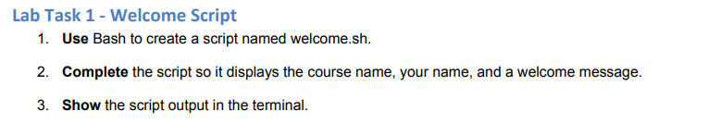

Commands:
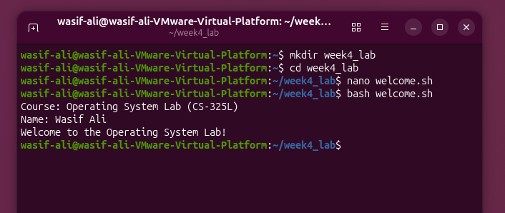
Script File:
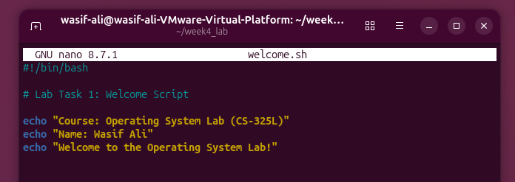

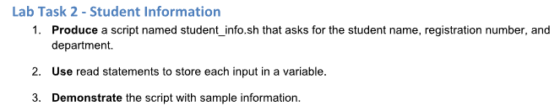

Script File:
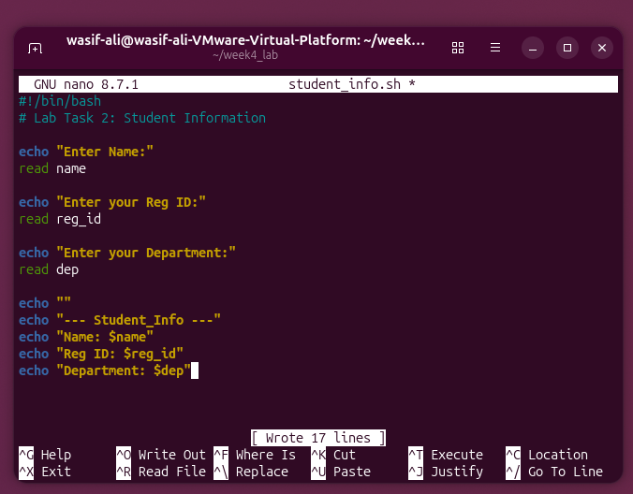
Commands:
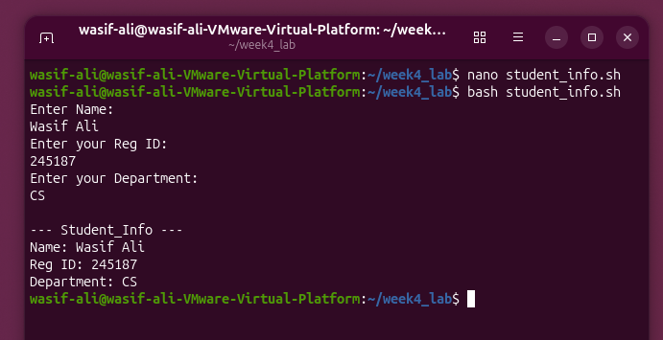
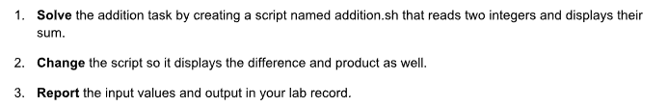
Script File:
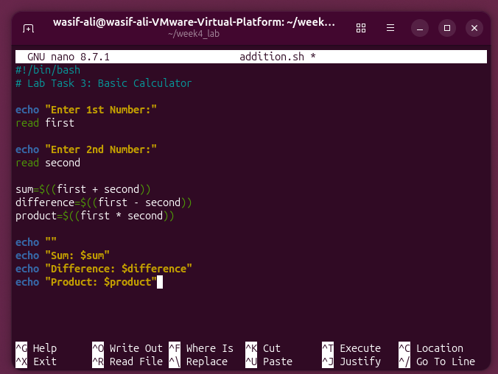
Commands:
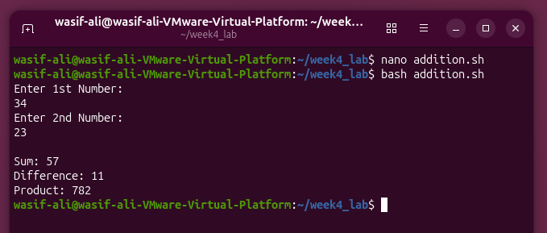

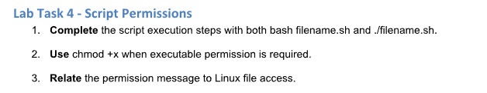
Direct Execution Attempt (Without execute permission):
When executing with ./filename.sh, the Linux kernel checks the file's execute permission bit (x). By default, newly created text files only receive read and write permissions (rw-).
Running via Interpreter:
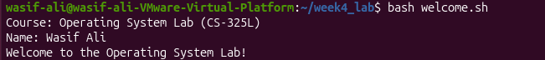
The script executes without an error because bash only needs read permission to open and interpret the file contents.
Granting Execute Permission:
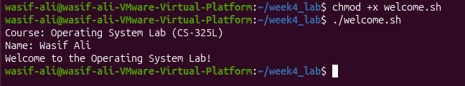
The script runs directly via ./welcome.sh because the chmod +x command adds executable permissions to the file mode flags.
Commands:
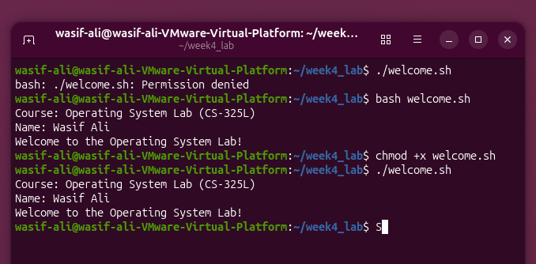

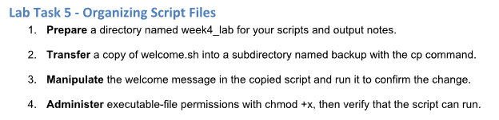
Commands:
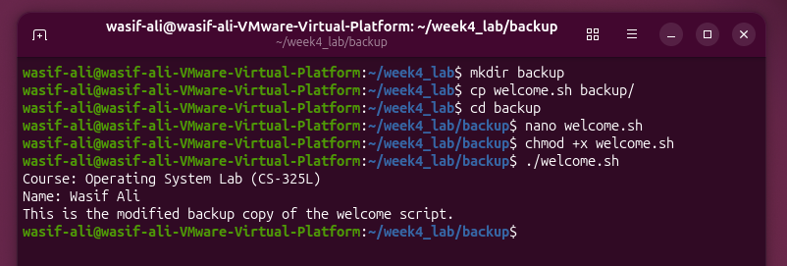

Script File:
